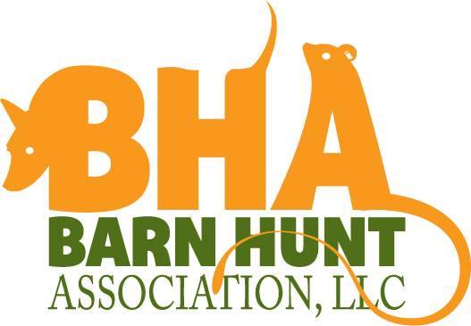

Barn Hunt Association Trial
Saturday Sept.27, 2014
Two trials offered same day

Hosted by:

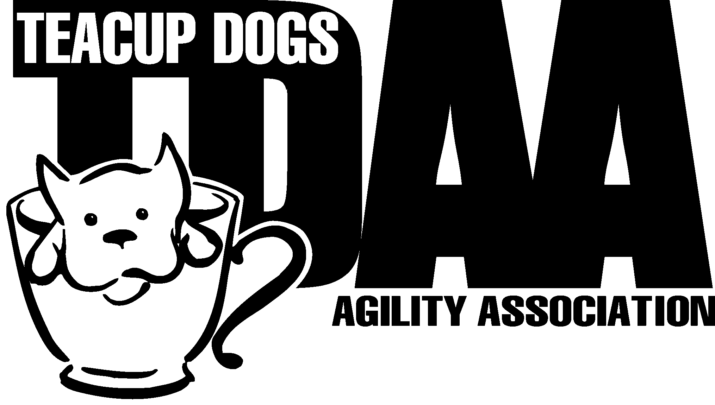
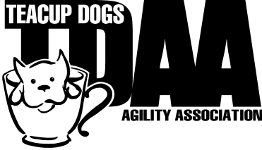
Pawsable K9 Events
Premium List
Permission has been granted by the Barn Hunt Association, LLC for the holding of these barn hunt trials under 2014 BHA Rules & Regulations

Location
290 Sweetmans Lane
Millstone Township, N.J. 08535

This trial is open to all breeds and mixed breeds of all sizes.
Must be 6 months of age to compete.
Opening Date Aug.1, 2014
Pre-entry closing date is Sept. 23, 2014 or until limits are met

We will be using 1 ring
Held outdoors under a pavilion
Classes offered:
Morning Trial
- Instinct test, Novice, Open, Senior, Masters
Afternoon Trial
- Novice, Open, Senior, Masters
We will run Instinct first and then run all classes BACK to BACK
Instinct, T1 Novice, T2 Novice,T1 Open T2 Open etc.

Limited to 125 runs for the day
No day of show entries

JUDGE: Gwen McCullagh, Skillman, NJ (All trial 2, Senior & Master Trial 1)
Judge- Catherine Brown, Livoria, NY (Instinct, Novice & Open- Trial 1)
Classes start at 8:00 AM
Measuring from 7:30 –7:45 AM
General Briefing at 7:45 AM

For more information, please visit the websites at:
www.barnhunt.com
www.pawsk9events.homestead.com

Pawsable K9 Events Trial Committee
Trial Secretary Trial Chairperson
Natalene Lamming Joyce Yaccarino
290 Sweetmans Lane 331 South Hope Chapel Rd.
Millstone Township, NJ 08535 Jackson, N. J. 08527
mousemoorjr@cs.com joyceyacc@aol.com

Show Site and Food
Bring chairs and crates.
Hospitality will be set up for morning coffee/tea and snacks for lunch
Bring a snack to share.
Please potty your dogs in the designated areas.

Directions to show site
From NJ Turnpike: Take Exit 8 to Rt. #33 east. Make right at Prodelin Way. Continue for approx. 4.4 miles. Road name changes to Perrineville Road then to Sweetmans Lane. Driveway is at top of the hill just after “Somers Court” and tractor crossing sign on left. Private Street Sign at drive says “Jack Russell Rd”

From Rt. #9 north or south: In Freehold, take Rt. #33 west to intersection Millhurst Rd. Take that jug handle. (Citco gas station on right) Road name changes to Sweetmans Lane. Go approx. 4.5 miles, Driveway is on right at the top of the hill just after “Chadwick Road” and tractor crossing sign. Private Street Sign at drive says “Jack Russell Rd”

Motels
Town House Motel, 351 Franklin St., Hightstown, N.J. 08520 - 609 448-2400
Days Inn, 460 East State Highway 33, East Windsor, NJ - 609 448-3200

BE SURE to check if the hotel still accepts dogs when making your reservations. Please make sure that you pick up after your dogs so that these hotels will continue to accept dogs.

Veterinary Clinics – 24 hour service
Northstar Vet Emergency Trauma Center  315 Robbinsville-Allentown Road  (off exit 7 I-195)  Robbinsville, NJ 08691  (609) 259-8300 | Garden State Veterinary Specialists  1 Pine Street  Tinton Falls, NJ 07753  (732) 922-0011

Awards:
- Ribbons will be awarded for 1st through 4th.
- Qualifying ribbons will be awarded to all dogs receiving a Qualifying Score.
- Title ribbons will be available for all completing a title.
- Title ribbons for RATI – Instinct test – First Qualifying Score.
- We will be using 2014 rules.

Notice to Exhibitors
The safety of the dogs is our primary concern. By entering this trial, exhibitors acknowledge that they are familiar with the rules and regulations of this sport and that their dogs are familiar with, and are able to perform all obstacles safely.
All dogs must be on leash or crated at all times except when in the ring. It is expressly understood that exhibitors alone are responsible for the behavior of their dogs and/or children. Any exhibitor whose dogs and/or children create unnecessary disturbances or repeatedly engage in unsafe or disruptive behavior may, at the discretion of the Trial Committee, be asked to leave the Trial site. In such case, no refund of any fees paid will be made.
Food and toys are not permitted in the course area and handlers are not allowed to use whistles or other instruments or devices.
Exhibitors are responsible for being at the ring gate when it is their turn to run.
Exhibitors may wear shirts or insignia of their training group if they wish.
Unsportsmanlike conduct, including rough handling or misconduct of any kind, will result in an excusal from the
Ring
Possessing or training with personal live quarry is not permitted on the show grounds at any time.

Eligibility
Your dog must be registered BHA to compete in a sanctioned trial. You may apply for a BHA number at: www.barnhunt.com It will take aprox. 48 hours to process.

Trial Entry Information
All pre-entries must be received by 6:00 PM on Sept. 23, 2014 after which time entries cannot be cancelled, altered, or substituted. Entries will not be accepted without the correct fees made payable to N. Lamming. No entries will be accepted which require a signature for delivery. All entries must be submitted on official Pawsable K9 BHA Entry forms, one dog per entry form.
Unsigned, incomplete or illegible entries are NOT acceptable and cannot be entered in the Trial. Faxed entries and/or credit cards cannot be accepted. Returned checks do not constitute a valid entry fee.

The Trial Secretary will add a $25 service charge for any returned checks. Subsequent returned checks from the same exhibitor may result in their being put on a CASH ONLY basis. Entry Fees will not be refunded in the event that a dog is absent, disqualified, excused or barred from competition by action of the Trial Committee.

No entry fee will be refunded if the trial cannot be opened or completed by reason of riots, civil disturbance, fire, an act of God, public emergency, an act of a public enemy or any other cause beyond the control of the organizing committee.
- Bitches in season (BIS) MAY compete at Barn Hunt Trials. They will be run at the end of each class. They MUST wear pants or britches at all times when they are not being pottied, including on the course.

Measured Height Divisions
Owners are responsible for entering the proper height division.
• Small dog – 13” and under
• Medium Dogs – 13.1” to 18”
• Large Dogs – over 18”

Classes Offered (Tentative Running Order) small to tall

Pawsable K9 Events Barn Hunt Trial Sept. 27, 2014
Closing date Sept. 23, 2014
Make Entry Fees Payable in US Funds to: N. Lamming
Mail Entries to: Natalene Lamming, 290 Sweetmans Lane, Millstone Township, NJ 08535

Actual Owner(s) (Please Print)________________________________________________________________________
______________________________________________________________________________________________
Street Address City/State/Zip
___________________________ ___________________________________ ______________________________
Phone Number e-mail address Call Name
________________________________________ _________________________
Registered Name BHA #
__________________ __ ______________ Dog’s measured height: ____________
Breed Sex Birthdate
Height class: S M L
Entry: $15.00 per class Circle Classes entered
Trial 1 Instinct test Novice Open Senior Master total $______
Trial 2 Novice Open Senior Master total $________
Total entries: $_______

Agreement
I (We) acknowledge that the “Barn Hunt Association Rules & Regulations” have been made available to me (us), and that I am (we are) familiar with their contents. I(We) agree to hold the BHA and any BHA approved judge and Pawsable K9’s harmless from any legal claim resulting from said judge’s action under the BHA Rules, Regulations and Guidelines. I (We) agree that the club holding the Barn Hunt Trial has the right to refuse entry for cause which the club shall deem to be sufficient. In consideration of the acceptance of this entry and of the holding of the Barn Hunt Trial and of the opportunity to have the dog judged, I(we) agree to hold harmless the directors, governors, officers, agents, superintendents or show secretary and the owner or lessor of the premises and any employees of the aforementioned parties from any claim for loss or injury which may be alleged to have been caused directly or indirectly to any person or things by the act of this dog while in or upon the show/trial premises or grounds or near any entrance thereto, and I(we) personally assume all responsibility and liability for any such claim, and I(we) further agree to hold the aforementioned parties harmless from any claim for loss of this dog by disappearance, theft, death or otherwise, and from any claim for damage or injury to the dog, whether such loss, disappearance, theft, damage or injury, be caused or alleged to be caused by the negligence of the club or any of the parties aforementioned, or by the negligence of any other person, or any other cause or causes.

I(We) hereby assume the sole responsibility for and agree to indemnify and save the aforementioned parties harmless from any and all loss and expenses (including legal fees) by reason of the liability imposed by law upon any of the aforementioned parties for damage because of bodily injuries, including death at any time arising out of or in consequence of my(our) participation in this Agility Trial, howsoever such injuries, death or damage to property may be caused, and whether or not the same may have been caused or may have been alleged to have been caused by negligence of the aforementioned parties or any of their employees or agents, or any other persons.
I certify that I am the actual owner of the dog, or that I am the duly authorized agent of the actual owner whose name I have entered above in consideration of the acceptance of this entry. I (We) agree to abide by the rules and regulations of the Barn Hunt Association in the premium list for this trial, or both, and further agree to be bound by the “Agreement” printed above. I (We) certify and represent that the dog entered is not a hazard to persons or other dogs. This entry is submitted for acceptance on the foregoing representation and agreement.

____________________________________________________ _________________________________________________________
Signature of Owner Parent or Guardian if under 18

Date _________________________________________ Handler ___________________________________________________

